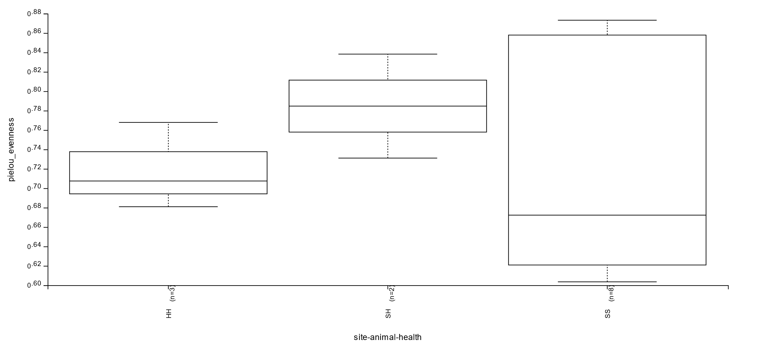Preliminary data exploration – sea star microbiome ecological genomics

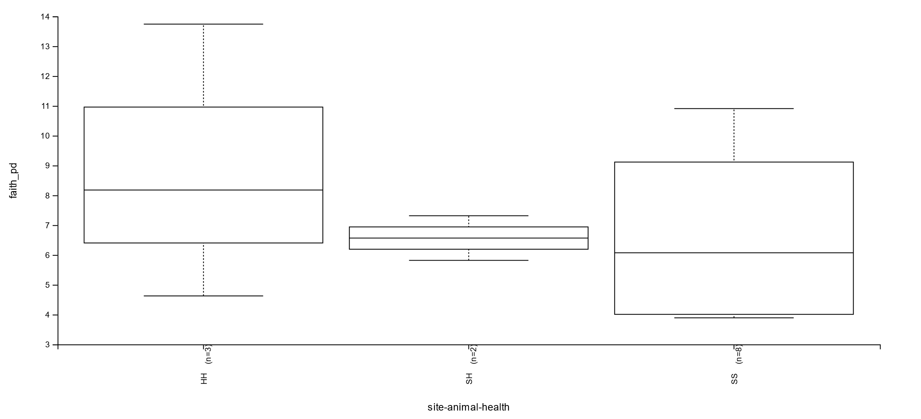Evenness is highly varied sick animals at sick sites. Healthy animals at sick sites seem to have the highest degree of evenness if we ignore the massive spread of SS animals

Phylogenetic diversity is low and less varied in healthy animals at sick sites – which is really interesting.

May need to change my cut offs or sequencing depth